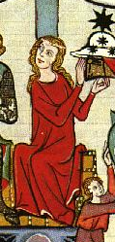

Cotte, Cyclas

and Veil

Dame Claire Tønnesdtr
Imperial Crown War 2005

The entry is a 12th – 13th century ladies cotte or
gown with pearl trim, A fringed silk cyclas
with pearl trim and a silk veil

The picture is from the Konstanz-Weingartner Leiderhandschrift
Circa 1265
Shows gown and fitted sleeve

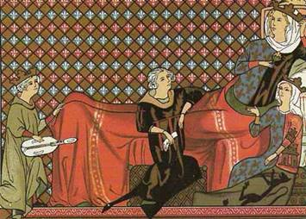

Queen Blanche of Castille with her attendants
Shows Cotte (gown) and veil.
(Miniature, French 13th C. Arsenal, Paris MSA5B.L)

The picture below was the inspiration for this cotte and the cyclas (overmantle). The noted historian and monk Matthew Paris chronicled the cyclas (cycladibus lat.) at the wedding of Henry III and Eleanor of Provence’s daughter in 1236, that many who witnessed the ceremony were dressed in cyclas worked with gold, over vestments of silk. Matthew goes on to say that “ the queen wore hers so long in front as well as behind as to trail upon the ground, and was held up with one hand lest her steps should be impeded.” However our monk does not stop there; he goes on to say “if the ladies feet and ankles be not small and delicate, to let their robes fall on the pavement to hide them; but those whose feet are beautiful may hold up the robe in front, under pretense of stepping out briskly.” He continues to bring his offended senses to the fore and compares the ladies present to “peacocks and pies (pied or piebald like a magpie) which delight in feathers of various colors; so do our court ladies. The pies have long tails that trail in the dirt, but the ladies make their tales a thousand times longer than the peacocks and the pies.” The king knew that Matthew was writing a history, and showed some anxiety that it should be as exact as possible. In 1257, in the course of a week's visit to St. Albans, King Henry III kept the chronicler beside him night and day, "and guided my pen", says Paris, with much good will and diligence.

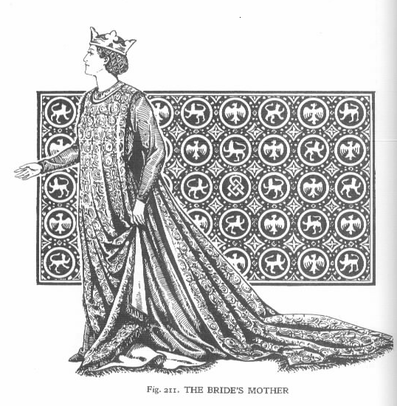

This image is from the Herbert Norris book; Medieval Costume and Fashion
and is based on Matthew Paris’s review of Eleanor of Provence at her daughters wedding.

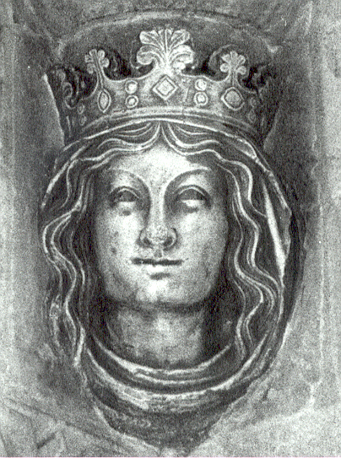
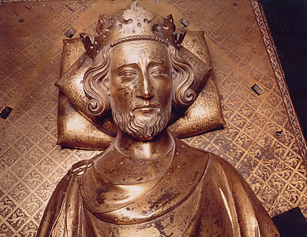

Effigy of Henry III
1290s
Bronze
Westminster Abbey, London

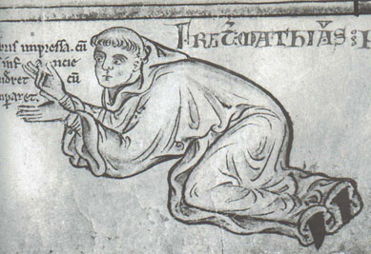
Eleanor of Provence
1290s
Bronze
Westminster Abbey, London

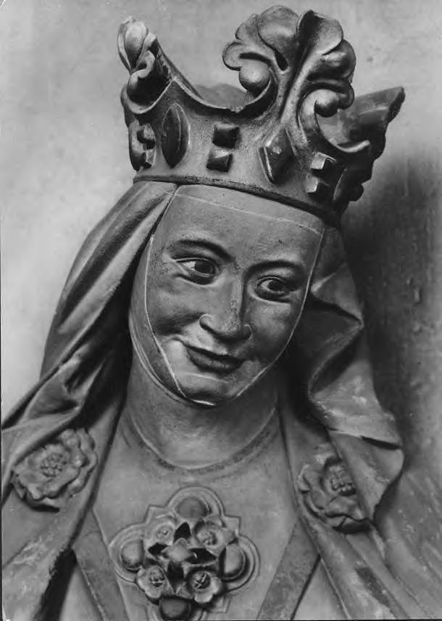

Illuminated Manuscript showing self-portrait of Matthew Paris
written about 1253

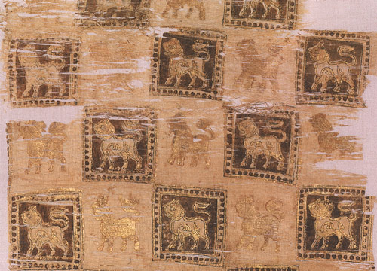

Textile Fragment with Printed Lions, 10th–11th century
Middle Eastern
Silk and cotton, printed; 17 3/4 x 39 in. (45.1 x 99.1 cm)
Gift of George D. Pratt, 1931 (31.106.64)
Metropolitan Museum of Art's collection of Islamic Art

Head of Adelheid c. 1260 Cathedral, Meissen
Shows veil, barbette and fillet

The fabric I used for the cotte is a heavy weave cotton with a brocade type print that I had on hand. I also had a large piece of silk for the cyclas, as well as a previous gown made of the same fabric, which had shrunk in the wash. I used my old gown to make a surcote for Sir Angus, and this made the most sense from a monetary point of view.

The construction of the cotte was rather simple; the sides have two gores each (from the side cuts) which is a typical construction technique from this period. The cut of the cotte itself was a very basic one, similar to a T-tunic with contrasting banding in a gold silk. The cotte was machine sewn for the most part, using poly-cotton thread, with only some hand stitching of the banding where necessary. The banding was cut to fit the neck and ends of the sleeves, and topstitched. The decorative gimp was also machine sewn onto the banding in a diaper pattern, and then real fresh water pearls were sewn at each crossing of the gimp.

The cyclas, or over-mantle was also a fairly simple construction; I cut it longer in the back to act as a train, but the front is also fairly long as shown in the picture. This garment was also machine sewn using polyester thread. I sewed in a few pleats into each shoulder to add the desired fullness. The cyclas is made of silk, and is self lined in silk; as well as interlined in a flannel to give it body and weight. I repeated the diaper pattern of gimp on the cyclas, and again sewed fresh water pearls at each gimp crossing. “Diapering” is often shown in many medieval sources as a repeating diamond or lozenge shaped pattern. The fabric shown behind Eleanor of Provence and the pattern on the wall behind Queen Blanche above are forms of “diaper” patterns. I finished the edges of the cyclas with a bullion fringe as shown in the illustration. I am amazed to report that there is more than 100 yards of gimp used on these two garments!

"Late Saxon Textiles from the City of London" Frances Pritchard, Medieval Archaeology, Volume 28, 1984 pp 46-76 + plates I to V The précis says:
"Archaeological Excavation’s in the city of London have produced an important collection of late 9th to early 12th Century textiles manufactured from wool, goat hair, silk and flax. The production processes associated with the different types of cloth are here described, together with details of weaving techniques and dying practices.
Evidence is examined for the local manufacture of cloth and for the import of foreign silks. Lastly, attention is drawn to the similarity of the London textiles to those found in other regions of Northern Europe."

On a casket depicting images from the cult of courtly love, made circa 1180AD in Limoges, France, in Limoges Champleve enamel. The women on the casket wear the sleeves that are tight to the wrist. However, the tippet is a long trailing piece of ornamental fabric that descends from the rear of the wrist to the floor, in a long flare, ending in a point. The tippet is often richly decorated with pearls or gems, or enamelling. In 1345-9, for example, Edward III's armourer John de Cologne made five hoods of white cloth for the King and his friends, each worked with blue dancing men and fastening at the front with buttons of large pearls. They required 2350 large pearls, together with velvet, silk and gold thread. These richly embroidered hoods were fashionable at the time and there are many entries listing the expensive requirements for them.
From: "Medieval Craftsmen: Embroiderers," by Kay Staniland, University of Toronto Press, 1991, pp. 46-48. ISBN: 0-8020-6915-0

Printed textiles were known during our time period; Rhenish items dated from the 12 through 15th centuries. The technique was to print a repeating pattern from wood blocks.
According to the text. the medieval patterns used approximate the patterns used in weaving brocade.
There is an extensive quote from Pliny as to the ancient process used, but little direct material on the medieval block stamping process. The author gives a reference to Forrer's "Die Kunst des Zeugdrucks" from 1898 which allegedly states that the Rhenish monasteries were cradles of block stamping textiles.
The author further states that the 11th- 14th c. Germans, lacking in ornate weaving adapted block stamping to decorate their textiles. Textile printing drops off following the 14th century as Germany enjoyed greater prosperity and and increasing use of woven and embroidered decorative elements.
Encyclopedia Britannica, 11th edition, vol 26 pp694 et. sq, Article by Alan Summerly Cole, C.B..

There is also a silk veil, oval cut of silk gauze with a hand-stitched rolled hem. I used silk thread for the hemming. It can be worn width or length wise, on top of the head, or folded in half and worn under the chin. Only ladies of nobility would have worn silk veils such as this. I wear it with a “fillet and barbette” as shown above. I have both a linen set of fillet and barbette as well as a silk one. Both of these sets are machine sewn using polyester thread. I cut the linen barbette on the bias to see if the small bit of stretch achieved from the bias would allow it to fit better, it does not. However, I still prefer to wear the linen set to the silk set as the silk set “rustles” when you wear it making it a bit difficult to hear while wearing it.
The fabric used for extant veils is described as being in a balanced tabby weave (a simple over-one under-one weave with a similar number of threads per inch in the warp as in the weft), lightweight with a very open, transparent look. The threads are heavily twisted in the same direction for both warp and weft (Z-twist or clockwise), giving a light crepe (crinkled) effect. As appropriate for a veil of this type, I used a narrow rolled hem. The hem indicated in Crowfoot, Pritchard, and Staniland. Textiles and Clothing c. 1150 - 1450. - was described as less than 1mm deep and with 5-6 stitches per cm. My hem is approx. 2-3 mm deep, but does have 5-6 stitches per cm.

"Textiles Cordage & raw fibre from 16-22 Coppergate" By Penelope Walton
Published by the York Archaeology Trust says:
Types of seams are mentioned in "Medieval Textiles from the excavations in the old town of Oslo" Anne Kjellberg and yet another seam in "The Analyses of the Textiles from Evebo Eide, Gloppen Norway" by Inger Raknes Petersen.

HEMS
The hem is the seam at the edge of a piece of cloth; how you sew the hem depends on how thick the cloth is. The rolled seam in figure 5 is only suitable for fabrics such as silk or very fine linen.
From the Museum of London's "Medieval Finds From Excavations in London" series. Crowfoot, Pritchard, and Staniland. Textiles and Clothing c. 1150 - 1450. Norwich, UK: HMSO, 1992 says:
Another form of hem particularly suited to fine silks is the rolled hem. This is less conspicuous than the double hem but demands more skill and manual dexterity as it cannot easily be pinned in place before sewing. The left hand rolls the raw edge and holds this in place whilst it is stitched by the right hand (Crowfoot, p. 158).

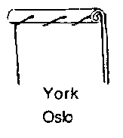
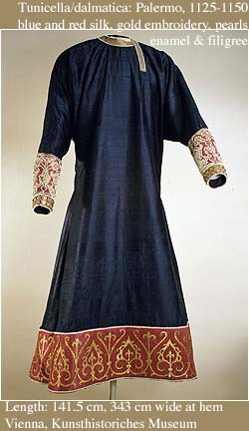
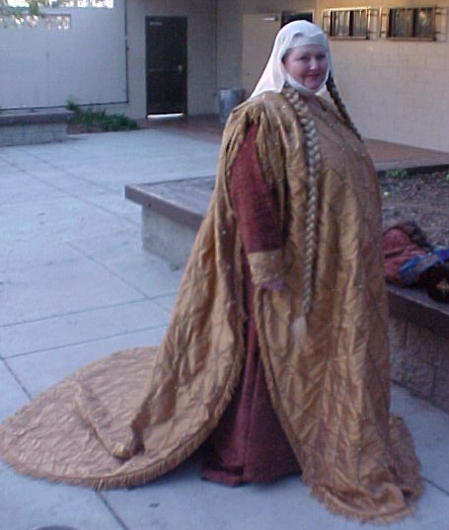
Gown, cyclas and veil showing fit and drape.

Blue & Red silk, Dalmatic sleeves, Kunsthistorische Museum, Vienna Palermo, Royal workshop, between 1130 and 1154
Purple silk with trimmings in red silk, embroidered in gold, gold filigree, enamel, and pearls.

12th Century Palermo.
(Tex12-Pal01)
Printed Bird & knotwork design.

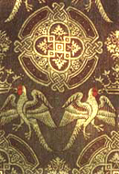
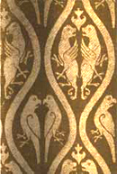

13th Century Germany.
(Tex13-Ger01)
Printed Bird & lozenge design.

Bibliography:

Norris, Herbert Medieval Costume and Fashion 1993 Dover Publications ISBN 0-486-40486-2

Laver, James Costume & Fashion; A Concise History 1969 Thames & Hudson Publishers ISBN: 0-500-20190-0

Kohler, Carl. A History of Costume 1963 Dover Publications ISBN: 0-486-21030-8

Payne, Blanche History of Costume 1965 Harper & Row

Regia Anglorium; Anglo Saxon, website, http://www.regia.org/textile1.htm

E. M. Carus-Wilson, Cloth and Clothing in Medieval Europe: Essays in Memory of Professor E. M. Carus-Wilson (Pasold Studies in Textile History, 2) Ashgate Publishing Company; (February 1984)

Crowfoot, Elizabeth: Pritchard, Francis: and Staniland, Kay. Textiles and Clothing c. 1150-1450. London: HMSO, 1992.

Crowfoot, Elizabeth; Pritchard, Francis; Staniland, Kay
Medieval Finds from Excavations in London, c. 1150-1450: Textiles & Clothing. HMSO, London, 1996

Egan, Geoff; Pritchard, Francis
Medieval Finds from Excavations in London, c. 1150-1450: Dress Accessories. HMSO, London, 1998

Walton, Penelope
"Textiles Cordage & raw fibre from 16-22 Coppergate" Published by the York Archaeology Trust London, 1989

Matthew Paris; Chronica majora. The illustrated chronicles of Matthew Paris: observations of thirteenth-century life; translated, edited and with an introduction by Richard Vaughan; illustrations selected by Nigel Wilkins; photography by Ian Cannell. (Dover, NH: A. Sutton, 1993).

Encyclopedia Britannica, 11th edition, vol 26 pp694 et. sq, Article by Alan Summerly Cole, C.B..

